How to log in to Deutsche Bank BluePort/bankline+ via photoTAN and authorize payments

If you haven’t yet installed the „DB Secure Authenticator“-app on your smartphone, you can download it for free from the Apple App Store or the Google Play store. As an alternative to the App, you can use a photoTAN reader.

Secure Login Method
— Visit the BluePort website https://blueport.db.com and enter your username and password.
— Scan the displayed code and receive a TAN on your smartphone or reader. Use it to log in.

Payment Transactions and Authorization via EBICS per „DB Secure Authenticator“-App

— Enter the payment details as usual in the entry screen of Deutsche Bank BluePort.
— Scan the displayed code and receive a TAN on your smartphone or reader.
— Check your payment details and enter the generated TAN: your payment order will be executed.
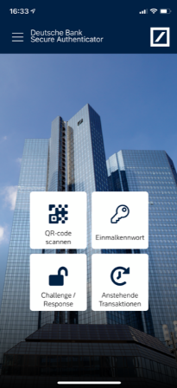

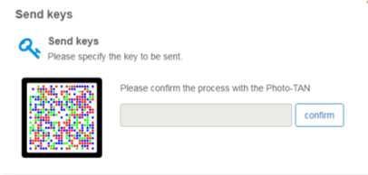

As an alternative to your smartphone you can use photoTAN with a special reader. Order a reader in the Online-Shop of Genostore.

Payment Transactions and Authorization via FinTS per 2FA procedure of your respective bank
— Enter the payment details as usual in the entry screen of Deutsche Bank BluePort/bankline+.
— In order to execute a payment order please use the authorization method (2FA) of your respective bank.

Guidance Notes on Security:
If you have lost your smartphone or it has been stolen, please delete the device immediately in Deutsche Bank BluePort/bankline+ in the left hand menue “change password/device” or contact us at: +49 (0) 69 910-10030 (customer service: Mon - Fri, 7:30 a.m. - 5:30 p.m., access blocking 24/7 possible).
If you sell your smartphone, please first uninstall the “DB Secure Authenticator” app from the device. Also delete the device in Deutsche Bank BluePort/bankline+ in the left hand menue “change password/device”.
In case of loss of your smartphone/reader or forgetting your password, please use your recovery code.

Find more information under deutsche-bank.de/BluePort
How to activate the photoTAN method
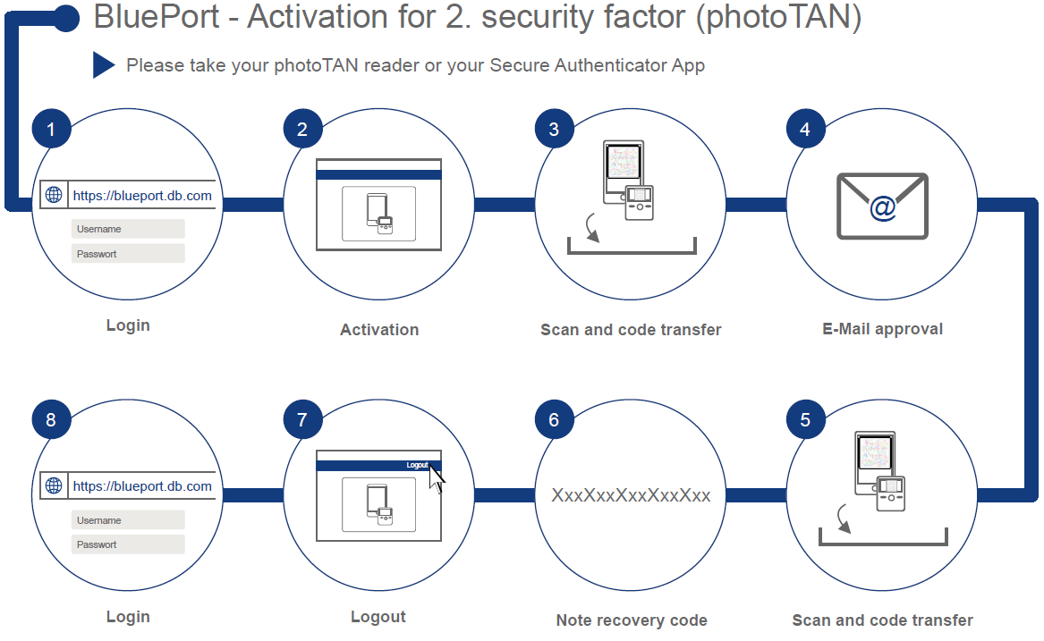
- Please open https://blueport.db.com in your browser and log in. You will be redirected to the self-service portal for activation of your app or reader. Click under „My Devices“ on „Activate“.
- To activate the app, start it, confirm the “Terms of use” and define your 6-digit access code to the app. For the reader, press the on/off button (middle) for 2-3 seconds to activate the app and click "Continue". Afterwards click on “Activate device” (applies to app as well as reader).
- Scan the QR Code in the self-service portal with your smartphone or reader. Then enter the 12-digit activation code in the self-service portal and click on “Next”. To confirm the input in the app, click on “Activate token”.
- You will now receive a confirmation link via e-mail; open that e-mail (not on your smartphone) and click on the “Continue” link.
- You will be provided with a new QR code. By scanning, another activation code is displayed, which you also enter in the self-service portal.
- A recovery code will now be produced in the self-service portal. Please keep it safe.
- By clicking on the user name in the upper right corner you get to the "Logout" function and exit the self-service portal. Close the browser window and open BluePort/bankline+ in a new window at https://blueport.db.com.
- You can now use Deutsche Bank BluePort/bankline+.

